# Slicing Index Values - Corrected

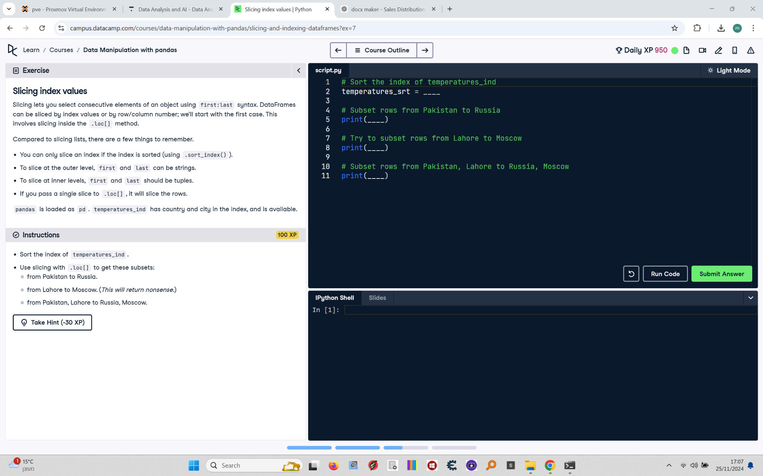

Slicing lets you select consecutive elements of an object using first:last syntax. DataFrames can be sliced by index values or by row/column number; we'll start with the first case. This involves slicing inside the .loc[] method.  
  
Compared to slicing lists, there are a few things to remember:  
- You can only slice an index if the index is sorted (using .sort_index()).  
- To slice at the outer level, first and last can be strings.  
- To slice at inner levels, first and last should be tuples.  
- If you pass a single slice to .loc[], it will slice the rows.  
  
pandas is loaded as pd. temperatures_ind has country and city in the index, and is available.

## Final Corrected Answer

# Sort the index of temperatures_ind  
temperatures_srt = temperatures_ind.sort_index()  
  
# Subset rows from Pakistan to Russia  
print(temperatures_srt.loc["Pakistan":"Russia"])  
  
# Try to subset rows from Lahore to Moscow  
print(temperatures_srt.loc["Lahore":"Moscow"])  
  
# Subset rows from Pakistan, Lahore to Russia, Moscow  
print(temperatures_srt.loc[("Pakistan", "Lahore"):("Russia", "Moscow")])